Assi – Network Topology
Draw and label diagrams of star, bus, and mesh network topologies on paper or using any drawing tool. For each, write one real-world app or service (like WhatsApp, Flipkart, or IPL streaming) that could use that topology and explain why in 1-2 lines.
Ans :
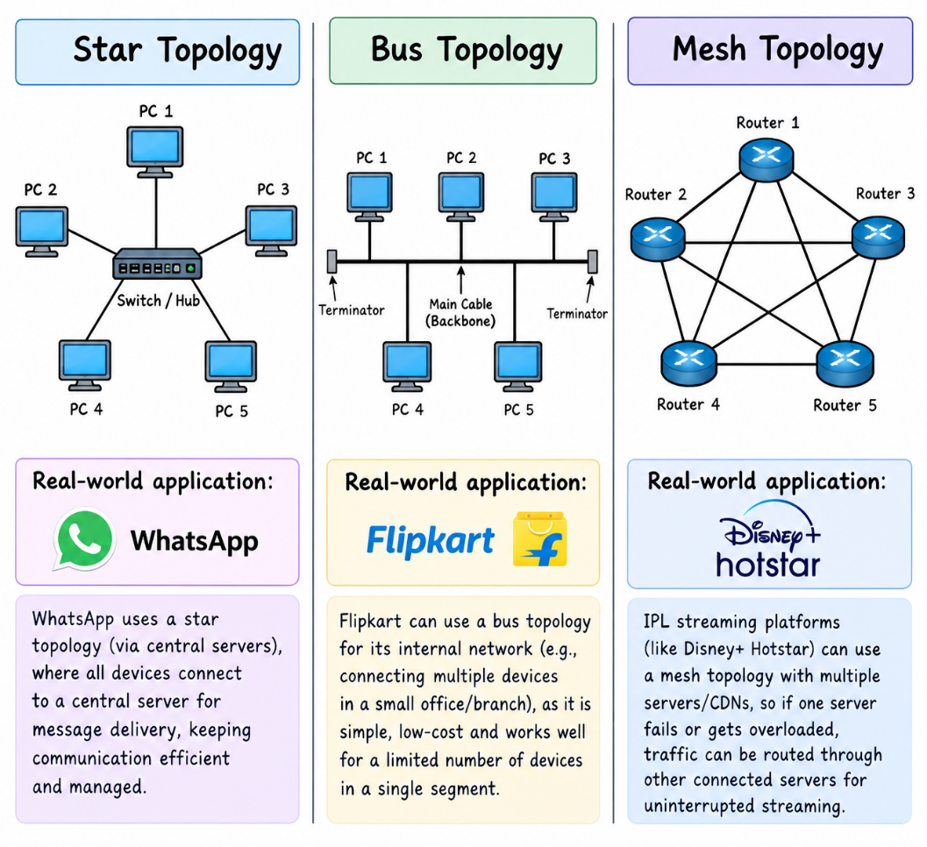

1. Star Topology
- Diagram: All computers are connected to one central switch or hub.
- Real-world application: WhatsApp
- Explanation: A star-like arrangement can represent devices connecting through central network infrastructure. WhatsApp uses servers to manage message delivery and communication.
2. Bus Topology
- Diagram: All computers are connected to one main cable called the backbone, with terminators at both ends.
- Real-world application: Flipkart (small office network example)
- Explanation: A bus topology can connect multiple devices through a shared cable. It is simple and low-cost for a small network, though modern Flipkart services use more advanced infrastructure.
3. Mesh Topology
- Diagram: Each router is connected to multiple other routers, providing alternative paths for data.
- Real-world application: Disney+ Hotstar (IPL streaming)
- Explanation: Mesh-like connections can provide alternative routes if one connection fails. This helps network infrastructure support reliable video streaming.

Create a comparison table listing at least four pros and four cons for each of these topologies: star, bus, ring, mesh. Include a column for 'Best Use Case' and give an example from apps you use (e.g., Instagram, Zomato, Paytm).
Ans :
Topology | Advantages (Pros) | Disadvantages (Cons) | Best Use Case | App Example
Star | 1. Easy to install. 2. Easy to troubleshoot. 3. Failure of one device does not affect others. 4. Easy to add new devices. | 1. Depends on the central switch. 2. Requires more cables. 3. Installation cost can be high. 4. Switch failure can stop the entire network. | Offices, schools, and computer labs. | Instagram — a star-like arrangement can illustrate devices connecting through central network infrastructure.
Bus | 1. Easy to set up. 2. Uses less cable. 3. Low installation cost. 4. Suitable for small networks. | 1. Main cable failure stops the network. 2. Troubleshooting is difficult. 3. Performance decreases with heavy traffic. 4. Limited cable length and number of devices. | Small, simple networks or older LANs. | Zomato — a shared cable can illustrate a small office network used by devices accessing an online service.
Ring | 1. Data travels in an organized path. 2. Predictable data transmission. 3. Can reduce collisions in token-based systems. 4. Each node gets a turn in token-based networks. | 1. A single link or node failure can disrupt a basic ring. 2. Adding devices can interrupt the network. 3. Troubleshooting can be difficult. 4. Data may travel through several nodes before reaching its destination. | Specialized industrial networks and some ring-based fiber networks. | Paytm — a ring can illustrate an organized path for data between network nodes; Paytm itself is not known to use this topology specifically.
Mesh | 1. Highly reliable. 2. Provides alternative paths. 3. No single link failure needs to stop communication. 4. Supports fault tolerance and redundancy. | 1. Expensive to install. 2. Requires many cables and ports in a wired mesh. 3. Complex to manage. 4. Configuration and maintenance can be difficult. | Data centers, backbone networks, and wireless mesh networks. | Instagram — multiple network paths can help illustrate resilient connectivity for a large online service.

Imagine you are designing a new multiplayer mobile game like PUBG or Free Fire. Choose a suitable network topology for the game servers and justify your choice in 3-4 lines, mentioning how it would impact speed, reliability, and cost.
Ans :
Chosen Network Topology: Mesh Topology
I would choose a mesh topology for a multiplayer mobile game like PUBG or Free Fire because it provides multiple paths for data transmission between servers.
- Speed: Alternative network paths can help reduce delays and maintain smooth gameplay.
- Reliability: If one connection fails, data can travel through another path, reducing downtime.
- Cost: It is expensive to set up and maintain because it requires extra connections and network equipment.
Note: In practice, multiplayer games usually use dedicated game servers connected through a carefully designed network rather than a fully connected mesh between every player.
I can also create a simple diagram showing how the game servers connect in a mesh topology.

Given this scenario: A small Flipkart-style warehouse wants to connect 8 computers for order processing and inventory updates. Recommend a network topology, sketch a quick diagram, and explain your reasoning in 2-3 lines.<br><br><em><strong>Hint:</strong> Consider factors like cost, ease of troubleshooting, and future expansion.</em>
Ans :
